I created a dictionary that makes suggestions for subjects to take at UoPeople for the upcoming terms. My keys are shorthand for the terms, y1 being year 1, y2 being year 2, t1 being term 1, t2 being term 2, and so on.

Each key correlates to a suggested subject, for example, this dictionary suggest I should take MATH1211 as a subject in the fourth term of my first year with the entry 'y1t4': 'MATH1211' of which the inverse entry is 'MATH1211': ['y1t4'] which is useful should I want to know when this dictionary would want me to take the subject MATH1211 without looking through the entire dictionary manually.

So, I can ask the dictionary in its original state, which subject should I take in year 1, term 3? And it will give me the subject suggestion MATH1201. And I can ask the inverted dictionary, in which term should I take BIOL1301? And it will give me the term suggestion year 2, term 3.

My code:

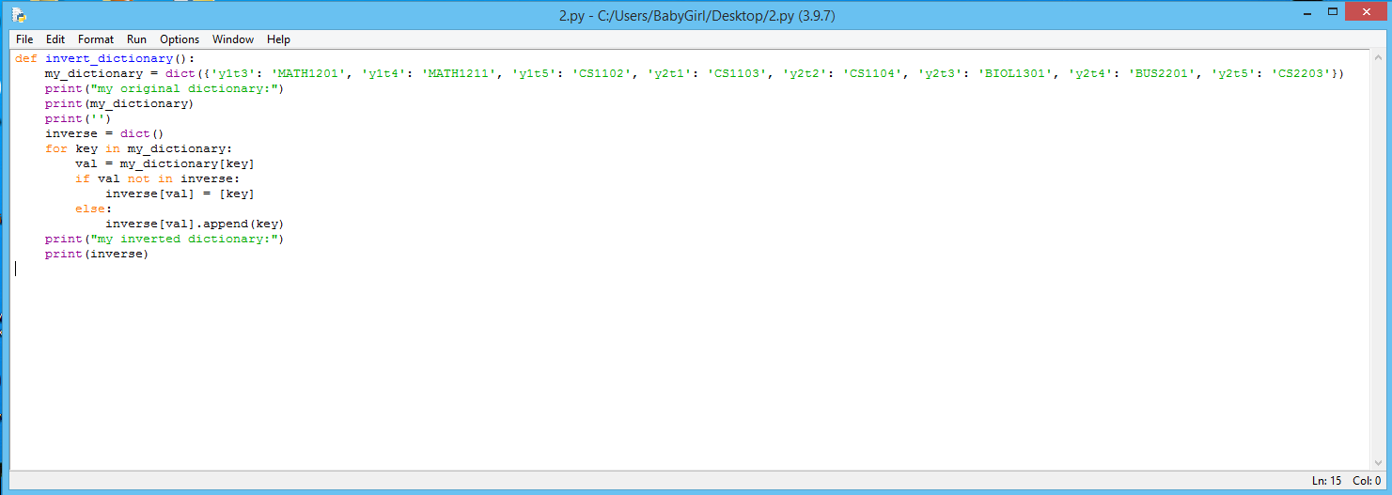

My output:

